PRACTICE 1
A. GRAMMAR
I. ASKING DISTANCE ( Hỏi khoảng cách)
How far is it from .......... to ..........?
→ It + is + (about) .................
Ex: 1/ How far is it from your house to school ? (Khoảng cách từ nhà bạn đến trường là bao xa?)
It is about 5 kilometers. (Nó khoảng 5km)
2/ How far is it from Ho Chi Minh City to Vung Tau? (Thành phố Hồ Chí Minh cách Vũng Tàu bao xa?)
→ It is not very far. (Không xa lắm)
II. USED TO - Đã từng( diễn tả thói quen trong quá khứ)
(+): S + used to + V
(- ): S +didn’t use to + V
(?): Did + S +use to + V ?
Ex: My grandfather used to play football when he was young.
C. EXERCISES
Exercise 1: Label the signs with the words/phrases below.
Danger Railroad Crossing Right Lane Ends
No Trucks Right Turn Ahead
Right Curve Ahead Watch Children
Emergency Vehicle Warning No Pedestrian Crossing

a.   | e.  
b.  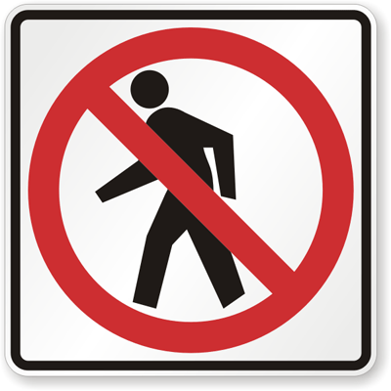 | f.  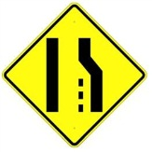
c.  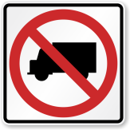 | g.  
d.   | h.  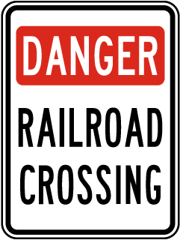
Exercise 2: Fill each blank with suitable words in the box.
is are it from
to walked jam station

1. How far it from your home to your school?
2. You will get stuck in a traffic if you go outside in the rush hour?
3. He usually to school when he was a child.
4. you in hurry?
5. Lana comes USA. She was born in a well-known family.
6. John used to immigrate Brazil. Have you ever been there?
7. is not very far from here to the warehouse.
8. I must go to railway to catch a train to my motherland.
Exercise 3: Make sentences using the words and phrases given.
1. Mr Thanh/ didn't/ to/ travel/ Korea.

3. How far / it/ Ha Noi/ Singapore/?

2. It/ about 250 km/ Ho Chi Minh City/ Da Nang.

4. Lan/ used / go/ on foot/ school.

- The end -
GVBM: 1/ Trần Lê Xuân Điệp (0949628449)
2/ Huỳnh Thị Hồng Loan ( 0358935251)

ANSWER KEY
Exercise 1: Label the signs with the words/phrases below.
a.  Watch Children | e.  Right Turn Ahead
b.  No Pedestrian Crossing | f.  Right Lane Ends
c.  No Trucks | g.  Emergency Vehicle Warning
d.  Right Curve Ahead | h.  Danger Railroad Crossing
Exercise 2: Fill each blank with suitable words in the box.
1. is 2. jam 3. walked 4. Are
5. from 6. to 7. It 8 . station
Exercise 3: Make sentences using the words and phrases given.
- Mr Thanh didn't used to travel to Korea.
- How far is it from Ha Noi to Singapore?
3. It is about 250 km from Ho Chi Minh City to Da Nang.
4. Lan used to go on foot to school.
___________________________________________

